For my soundscape I decided to make a story about someone (you) being tasked with going to Hell and shutting down a gate between hell and the overworld. As such, I wanted the atmosphere to be dark and somewhat stressful. As such I created a “Blowtorch” effect with a virtual instrument and some gain, then looped the sound so it can be heard underneath through most of the piece. I also added some sounds of thunder, crackling fire, and composed a little F minor bassline on a sub bass synth. At the start I also used some sounds of heavy breathing, which I recorded myself, and a heartbeat in order to create a sense of tension and urgency. I felt that these sounds together created the right setting for the fight to take place. The image below is some of the ambient tracks I used for the background noise.

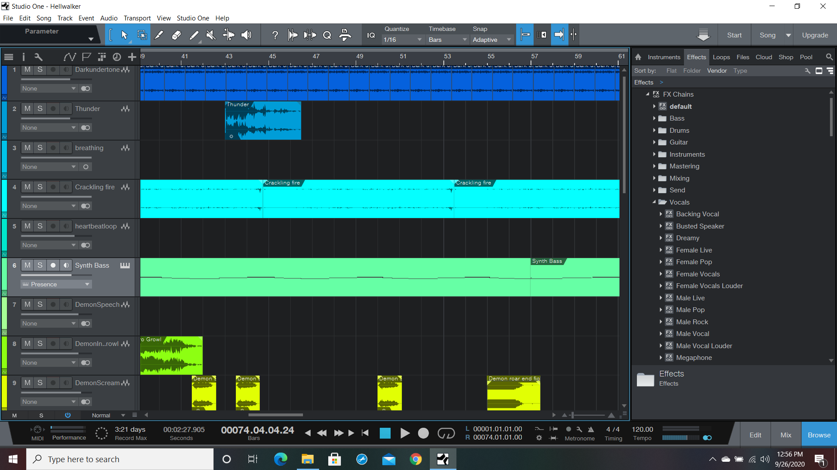

For the bulk of this soundscape the main character is engaged in a fight with a demon. This fight turned out to be my greatest challenge in creating the soundscape. The main reason for that is conveying motion through sound can be a bit difficult, and in my experience has a lot to do with the timing between certain elements. My theory was that if I can demonstrate the fight becoming closer and closer distance I can create a sense of flow within that. So that is why there is standard machine gun fire (distance), shotgun fire (a bit closer), and then sounds of hand to hand combat to bring it home. The below image is the beginning of the fight sequence.

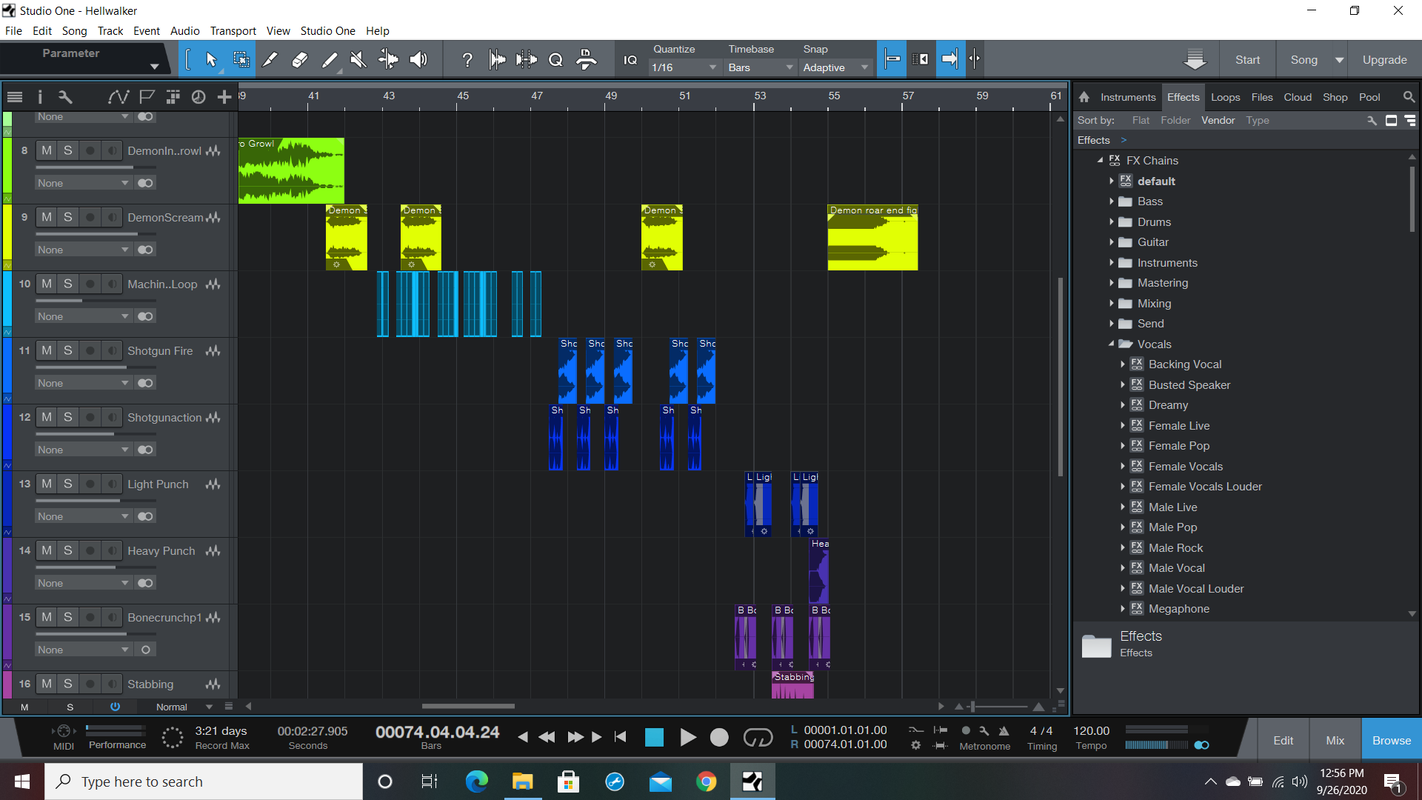

Overall, I wanted to create a stressful environment and to do so I had constant, loud sound through the course of the soundscape.